Hello Team SELAC,

What a great weekend we had last Saturday. Let’s keep it going this weekend.

Congratulations to Alyssa McDrury for breaking the long standing club record in the under girls 12’s long jump, with a very impressive jump of 4.69m. Alyssa now holds the U9, U10, U11 and U12 long jump records.

Also well done to all the athletes who achieved PB’s on Saturday. There were 206 new PB’s across the club. It’s awesome that you have started to improve so early in the season. About half of those athletes who produced new PB’s have attended some of our SELAC training sessions in the first week.

Get along to training and start collecting those PB’s!!!!

SELAC Training sessions
It was our first full week of training sessions and we had a great turn out. With up to 11 training sessions available for athletes to attend, we have tried to cater for everyone and we are still looking to grow the number of coaches we have over the next couple of weeks. Please see the training schedule attached and sign up using the link:
https://forms.gle/EGXHQrcDvsG1zG6e7

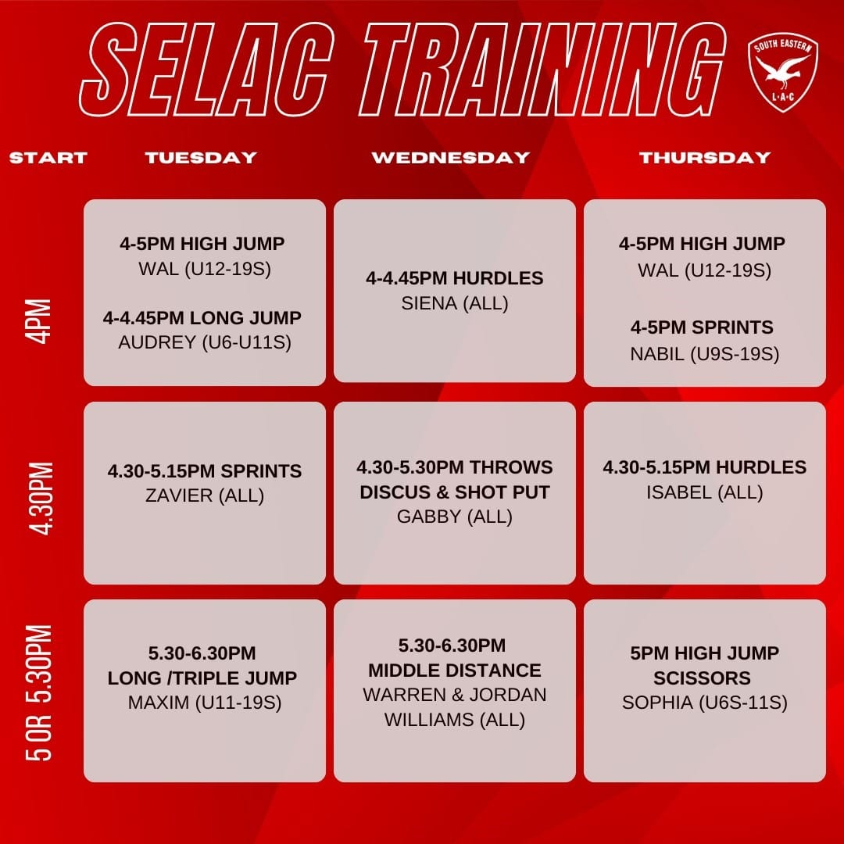
If you want to attend SELAC sponsored training you need to sign up and pay before you start.

SELAC Trials – Continue for another couple of weeks. If you have completed 2 weeks with us, please register before joining us on Saturday.

Tots Age Marshal - We are looking to identify an age marshal or 2 people to share the role who would be willing to take on the Tots group. The tots program is based on fun and incorporates athletics-based skills. No previous athletics knowledge or training is required and we will provide you with a former Selac athlete to assist with your weekly program until you feel comfortable.

SELAC Senior Athletics club - Athletes are now able to register to compete in ANSW senior events while representing South Eastern Little Athletics.

Please see the link below if you are interested in registering for senior athletics with our club, we have kept the fees as cheap as possible to encourage people to try senior athletics. https://www.revolutionise.com.au/selac/registration/

PB-Athon
The PB-Athon continues... Jaide and the club captains will be encouraging all athletes to join in.

SELAC Club championships
2023 CLUB CHAMPIONSHIPS REGISTRATION ARE OPEN!

South Eastern Little Athletics Club Championships will be held over 2 weekends on Saturday 28 October and Saturday 4 November (with the exception of the 3000m which will be held on another program 1 week). Medals will be awards for 1st, 2nd and 3rd places.
Entry cost is $10 per athlete - for up to 5 events.

How do I register for club championships:

1. Fill out the form below for the athlete (if you have multiple athletes you will need to complete one form for each).

2. Transfer the appropriate amount to the bank details below:
Instructions for Payment Transfer:
Account Name: South Eastern Little Athletics Centre Inc
BSB: 012-396
Account Number: 4937-13606

Reference: Name and Age Group
A “reference” is essential so we can match the payment to your child.

A single family payment for the total Championship amount can be made in one transfer and then uploaded with each family athlete registration.
3. Take a screen capture of your transfer and upload via this form.

Both the online form and payment need to be received by SELAC before your child/ren can compete.
Parental assistance on the days is expected and essential in ensuring the successful staging of the Club Championships. Please see the club championship event list to determine which events you are eligible to enter. Should you have any questions, please speak to your age marshal, Matt - president@southeasternlac.org.au or Theresa - vicepresident@southeasternlac.org.au

Entries for the Club Championships close on Tuesday 24 October 2022. Entry here: https://forms.gle/RFQNDauzhJ9D1H6e6
ONLY REGISTERED ATHLETES CAN COMPETE AT OUR CLUB CHAMPIONSHIPS
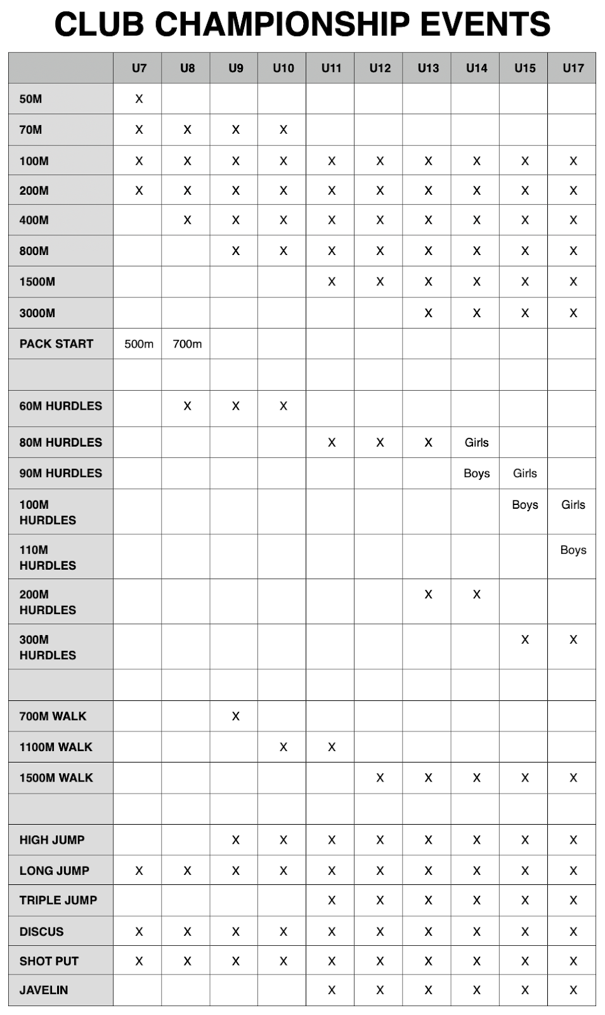

Sponsors – the club is always on the lookout for new sponsors, if you have any thoughts, please contact Matt or Theresa.

The Runners Shop at Randwick has agreed to support the club this year. Robyn will be down on the 21st of October to set up a pop up shop again for those athletes who need new gear.
If you can’t wait that long, drop into the shop on Clovelly Road, ask for Robyn, mention you are with SELAC and she will help you.

Please see the link to their web site - https://runnersshop.com.au/

General Information;
Track & Field Status (new program attached) - We are on program TWO (2) this week.

Registration numbers - Please attach the numbers to uniforms if you have them.

On the Day
Set-up is from 7.15am. Please make sure that as many parents as possible lend a hand to set-up.
Matt will be coordinating the Walks and any seniors that wish to run the 3000m at 7.45am.
8am with the P300 (U6s), P500 (U7), P700 (U8), 800m (U9 & U10) 1500 (U11s upwards). The long hurdles will run in parallel with these. We will then have the 50m and 100m sprints followed by the 400m.

See you all on Saturday.

Selac Committee

